How to Print Gentle Balanced Leadership Poster

The Gentle Balanced Leadership poster measures 297 x 420 mm (11 x 17 inches). In order to print the poster on a standard sheet of paper, please follow these steps:

* Open the PDF document
* Go to File -> Print
* Select either Fit **or** Shrink oversized pages:

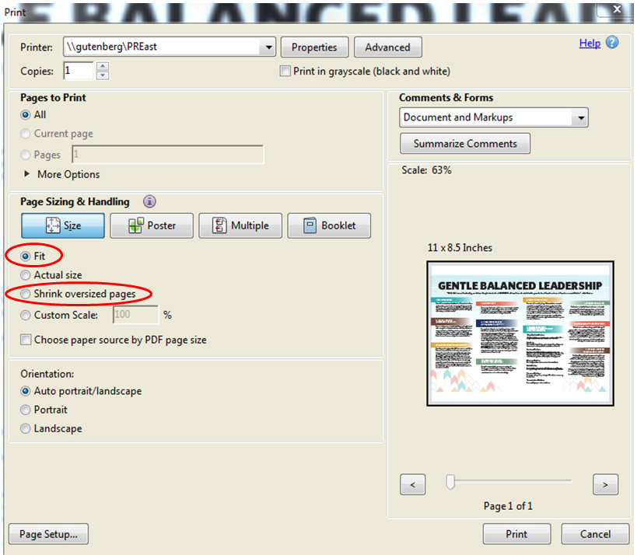

* Select Print